Hybrid Binary Search for Critical Clearing Time (CCT)
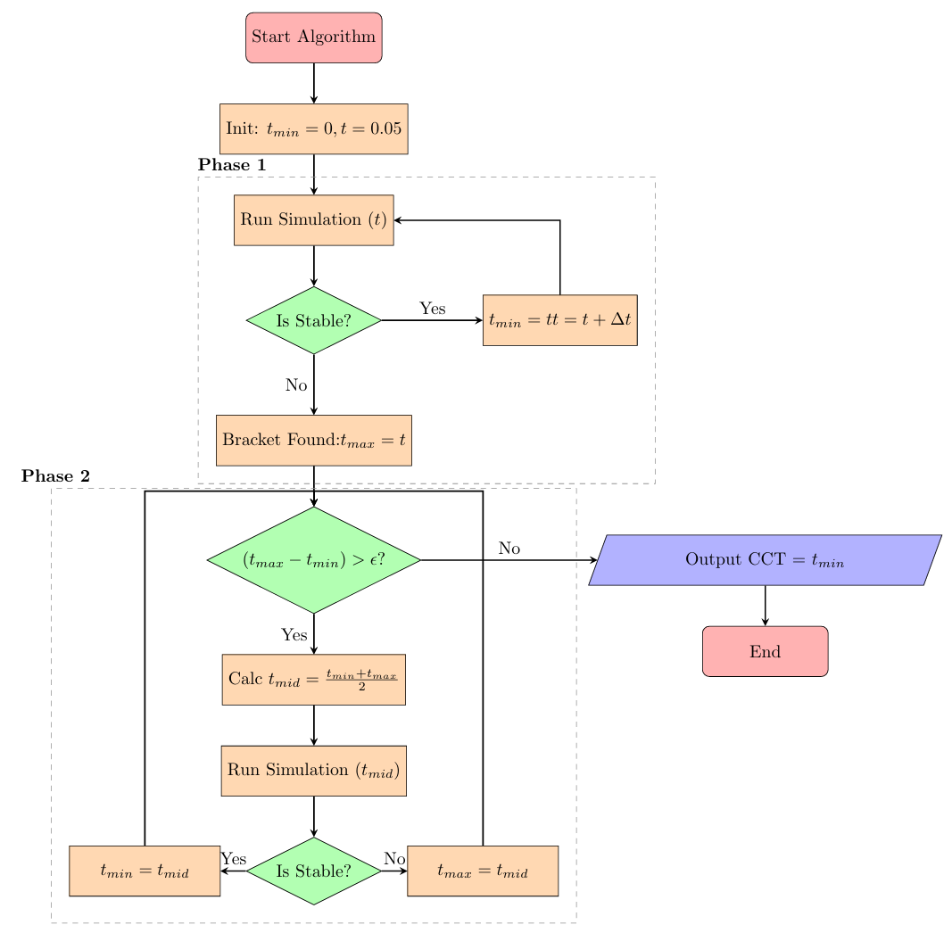
Figure 1: Flowchart of Hybrid Binary Search Logic

Algorithm Explanation

Phase 1: Bracketing (Coarse Search)
The objective of the bracketing phase is to identify an interval [t_min, t_max] that contains the Critical Clearing Time (CCT). This phase performs a coarse search by progressively increasing the fault clearing time until system instability is observed. We run the simulation of suppose time t1, then check the stability based on the difference of maximum and minimum angle. If the spread is less then 180 degree the system is stable if it is greater than 180, it is unstable.
1. Initialization: The lower bound is initialized as t_min = 0. An initial clearing time t = 0.05 s is selected for simulation.
2.Search Process: Time-domain simulations are performed repeatedly using PSS/E, increasing the clearing time by a fixed step Δt = 0.05 s at each iteration.
3.Stability Check: After each simulation, the system stability is evaluated based on spread of rotor angle. If the spread is less than 180 degree the system is stable but if it is greater than 180, it is unstable.
4.Transition Condition: If the system remains stable, t_min is updated. Once instability is detected, the current clearing time is assigned as t_max and the algorithm transitions to Phase 2.

Phase 2: Bisection (Binary Search)
The bisection phase refines the Critical Clearing Time within the interval [t_min, t_max] obtained from Phase 1. This phase applies binary search to achieve higher accuracy with fewer simulations.
• Tolerance Check: The algorithm verifies whether the interval (t_max − t_min) exceeds a predefined tolerance ε. If so, further refinement is required.
• Midpoint Calculation: The midpoint clearing time is computed as t_mid = (t_min + t_max) / 2 and tested through simulation.
• Interval Update: If the system is stable at t_mid, it becomes the new lower bound (t_min). If unstable, it becomes the new upper bound (t_max).
This iterative process continues until the interval width falls below the tolerance ε. The final value of t_min is taken as the estimated Critical Clearing Time.

